SUZYMARI HEALTH & FITNESS STUDIO
100 Westmore Drive Unit #27
Toronto, Ontario M9V 5C3
Tel: 416-746-2431
Email: suzy@suzymari.ca

Membership Policy

NAME: ______________________________________ AGE: _________ DATE: __________________
ADDRESS: ______________________________CITY: ___________PROVINCE_____________________
POSTAL CODE: ________________ EMAIL: _________________________________________________
PHONE: (H) _______________________ (C) _____________________ (W) _______________________
New Client ______ Renewal Client _______

Thank you for choosing a fitness program with SHF. We want you to feel 100% comfortable with your personal fitness programs. Our goal is to help you achieve the results you are looking for and to make your experience with SHF an enjoyable one. In exchange for services, you agree to make payments in the total amount on the terms set out below and all charges under this agreement.

“Let’s Get Fit, Have Fun and Look Fabulous!”

Commitment to your lifestyle change
- Client agrees to arrive 10 minutes prior to his/her schedule appointment. If client arrives late for any session, your appointment will finish at the originally scheduled completion time.
- You agree that if you feel lightheaded, dizzy, nauseous or experience pain or discomfort at any time during a training session, you will immediately stop activity and inform your trainer/instructor.
- You agree to inform your trainer/instructor of any condition or changes in your health at anytime while participating in the program, which might affect your ability to exercise safely and with minimal risk of injury.
- You are not obligated to perform or participate in any activity unless you want to, and have the right at any time to decline participation in a session/class.
- You agree to provide at least 24 hours notice if you wish to cancel or reschedule your appointment.
- Any sessions/classes missed due to illness or an uncontrollable circumstances—sessions can be “banked” and completed at the end the session.
- Client agrees to follow all prepared eating plans, as this is an important part to your success and achieving your goal.
- Client must understand that, being consistent is always a vital part in anyone achieving their fitness goal—it is expected that client follows all exercise program set out by their trainer/instructor.
- Client agrees to complete all training sessions/classes within specified time—failure to do so, may result in loss of session for the client. Unless otherwise discussed.
- Agreement Start Date: __________________Agreement End Date: ___________________. For Personal Training, sessions must be completed within 3 to 12 months and of the purchase dated.
- I have carefully read this Fitness agreement and understand the terms and conditions and agree session to be bound by them.
WAIVER
I, the undersigned, accept full responsibility for my use in all apparatus, programs, facility privilege or service operated at, in or by SUZYMARI HEALTH & FITNESS STUDIO. I will hold SUZYMARI, its directors, offers, employees, consultants, representatives, members and agents harmless from any and all loss, claim, damage, liability or injury up to and including death sustained or incurred by me resulting from them. I have informed my physician of my intent to peruse Personal training or participate in a group exercise program and have his/her approval or have provided SUZYMARI HEALTH & FITNESS STUDIO with a physician’s release form if applicable. I understand that SUZYMARI HEALTH& FITNESS and its employee, staff, consultants are not responsible for my actions, and that if I am in doubt at any time about any part of my fitness training or recreation, I will consult my personal physician.

CANCELLATION POLICY
Sessions that are cancelled with less than twenty four (24) hours are charged the full session.
I understand that PERSONAL TRAINING, BOOT CAMP AND GROUP CLASES are non-refundable or transferable.
All monthly contracts need to be canceled thirty (30) days prior to the billing date (15th of every month).

  - TYPE OF PROGRAM:
___ Fat Loss ___ Personal Training ___ Group Training ___ Group Fitness Class

___Specialties Fitness program _______________________________________
  - PAYMENT PLAN
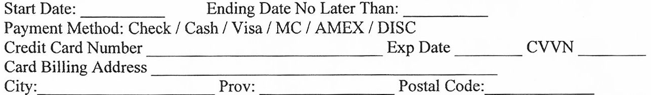
I _________________ authorize SuzyMari Health & Fitness Studio to withdraw payments automatically from my account/credit card monthly/bi-weekly.

Number of Sessions ___________ (1) hour Training_________ (2) hours Training
Rate per Session______________
Discount ________________
Cost of Program ______________ 1ST PAYMENT_________________
HST ______________ 2ND PAYMENT_________________
Total Cost _______________ 3RD PAYMENT___________________
Amount Paid _______________
Balance Owed _______________ 4TH PAYMENT__________________
BI-WEEKLY
MONTHLY PAYMENT AMOUNT: ___________ 5TH PAYMENT__________________

Staff Signature_________________________
Participant Signature____________________

*All monthly contracts require a Credit Card on file, Visa, MasterCard, American Express. Monthly contracts are a minimum of twelve (12) months. First and Last payment had to be paid up front. All monthly contracts need to be canceled thirty (30) days prior to the billing date (15th of every month).

